Java backend and database
28/02-2026
Software’s required
- JDK 21
- Eclipse IDE for enterprise developers

Java is a platform independent & object oriented programming language.
Object oriented language means you can create real world entities in the application which will have properties and behaviors
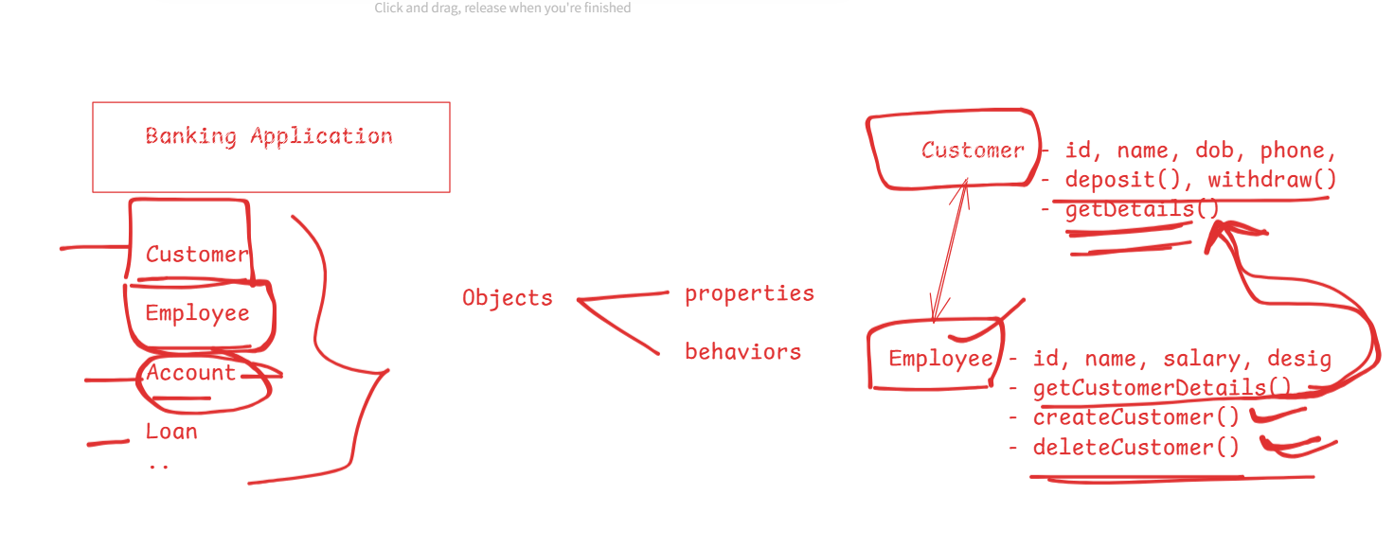
Platform independent means you can compile the program once and run on any platform without recompiling.
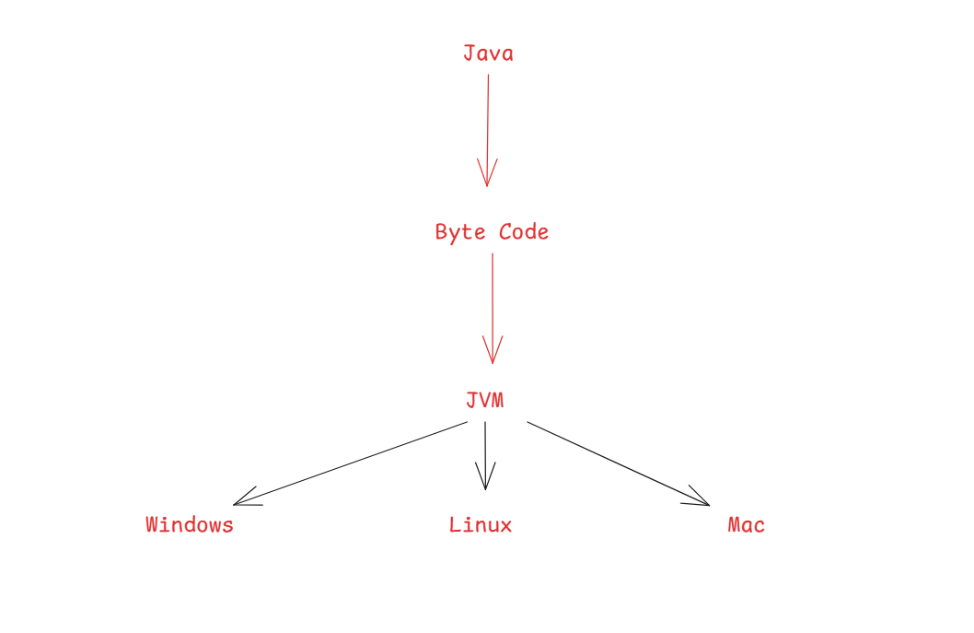

Building blocks of an object oriented language
- Class - template of an object
- Object - instance created from the class
class class_name {
variables
costructors
methods
}
class_name must begin with upper case letter and follow camel case
variables & methods must begin with lower case letter and follow camel case
constructors name will be same as the class name
Example of a class
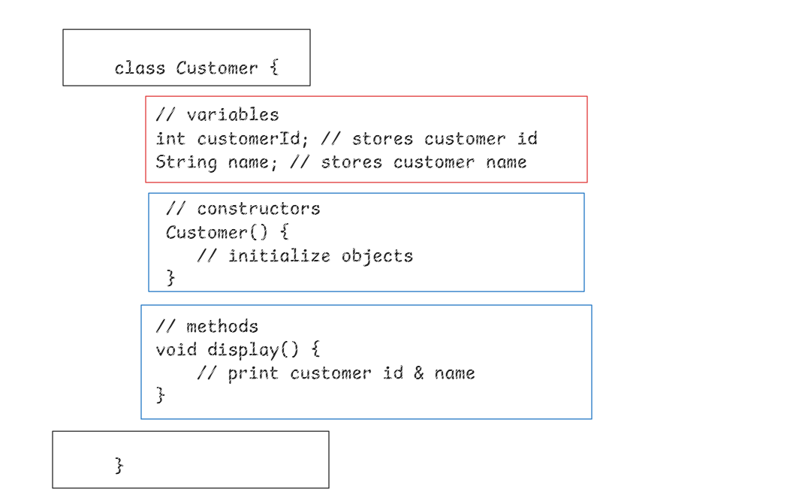

Fundamentals of Java
- Datatypes
- Variables
- Operators
- Conditional Statements
- Loops
- Branch Statements
- Arrays
- Classes and Objects
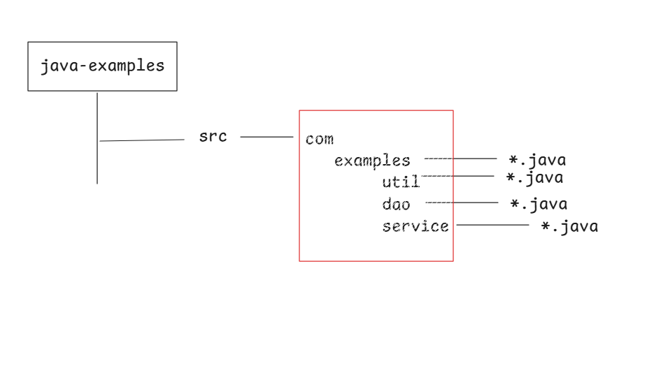
Datatypes and Variables
Variables: These are memory with names what can store values, you can create variables with datatypes
Datatypes: These specify what kind of data a variable can store.

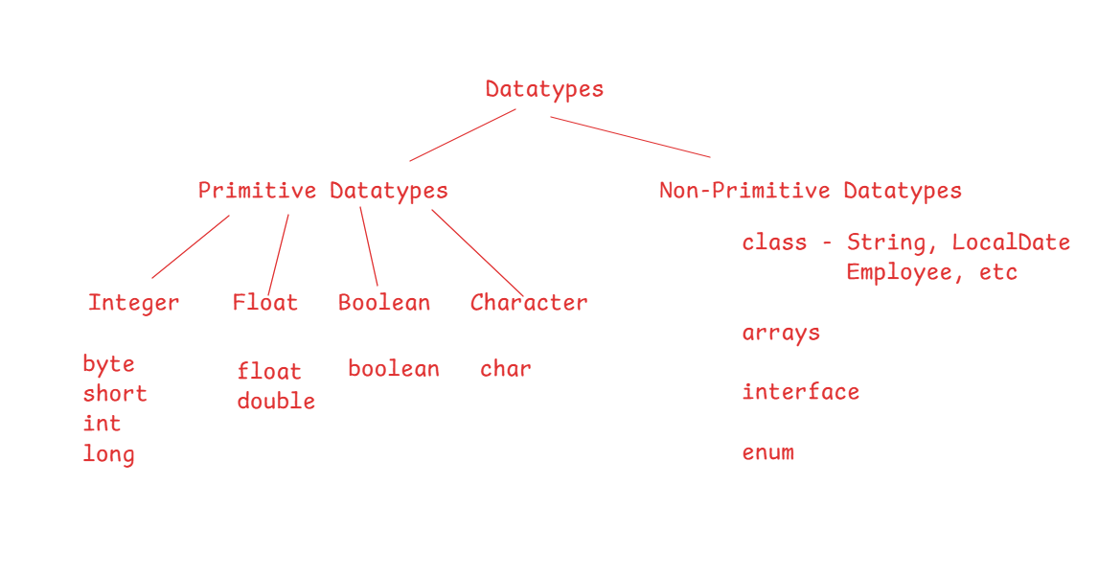
Primitive datatypes size are fixed
Primitive types | Size (bytes)
byte | 1
short | 2
int | 4
long | 8
float | 4
double | 8
boolean | 1
char | 2

These datatypes are used to declare variables and also mention the returns types for the method.
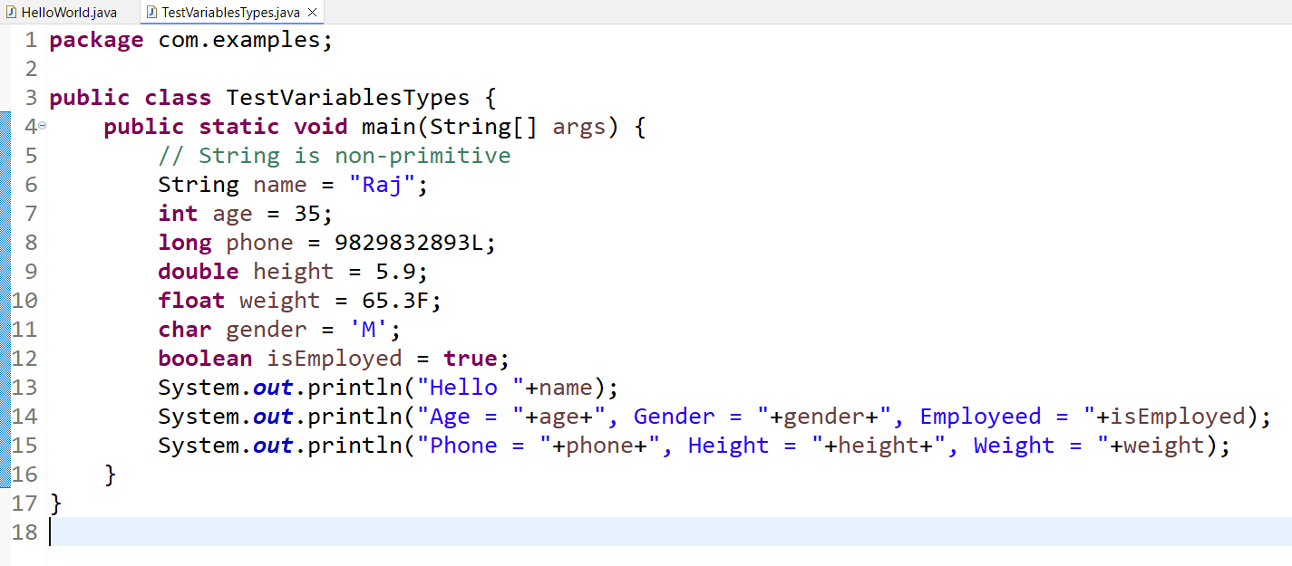
Output:
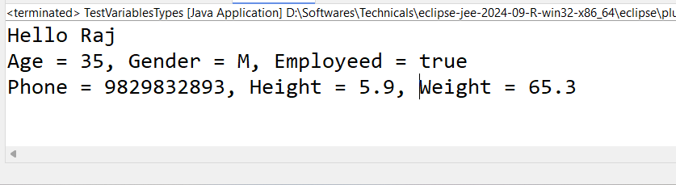

Operators
Operators are special symbols used to perform operations on variables and values
Type of operators
- Arithmetic operators: +, -, *, /, %
- Unary operators: ++, --
- Assignment operators: =, +=, -=, *=, /=
- Relational operators: ==, !=, <, >, <=, >=
- Logical operators: &&, ||, !
- Bitwise operators: &, |, ^
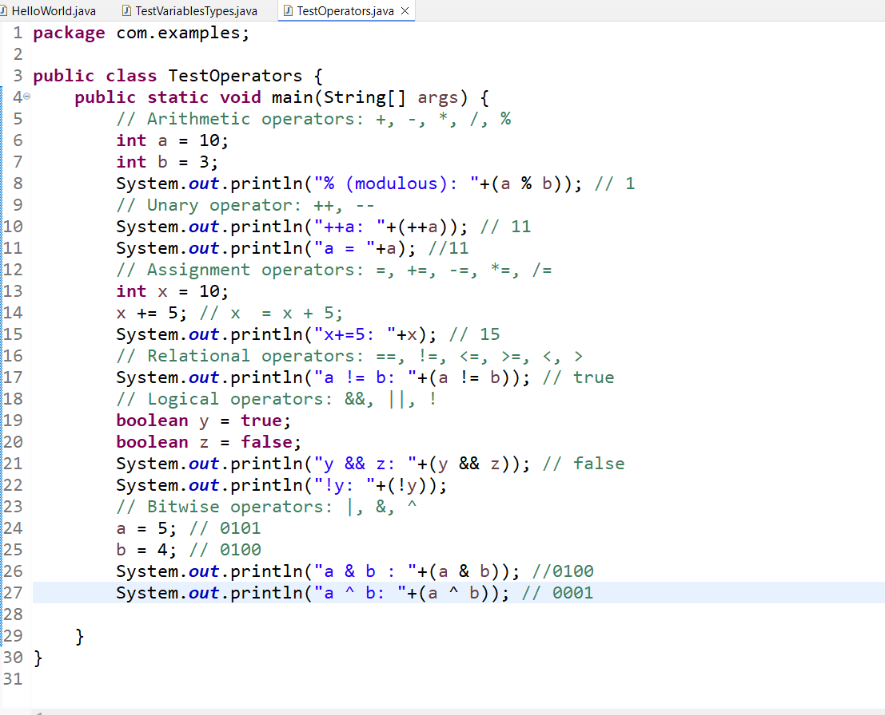
Output:
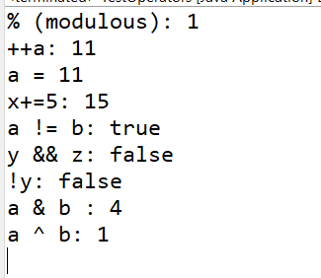

Conditional Statements:
Whenever you want to execute set of statements whenever certain condition match we can use following conditional statements.
- if
- if else
- if else if else if … else
- switch
- ternary ?:
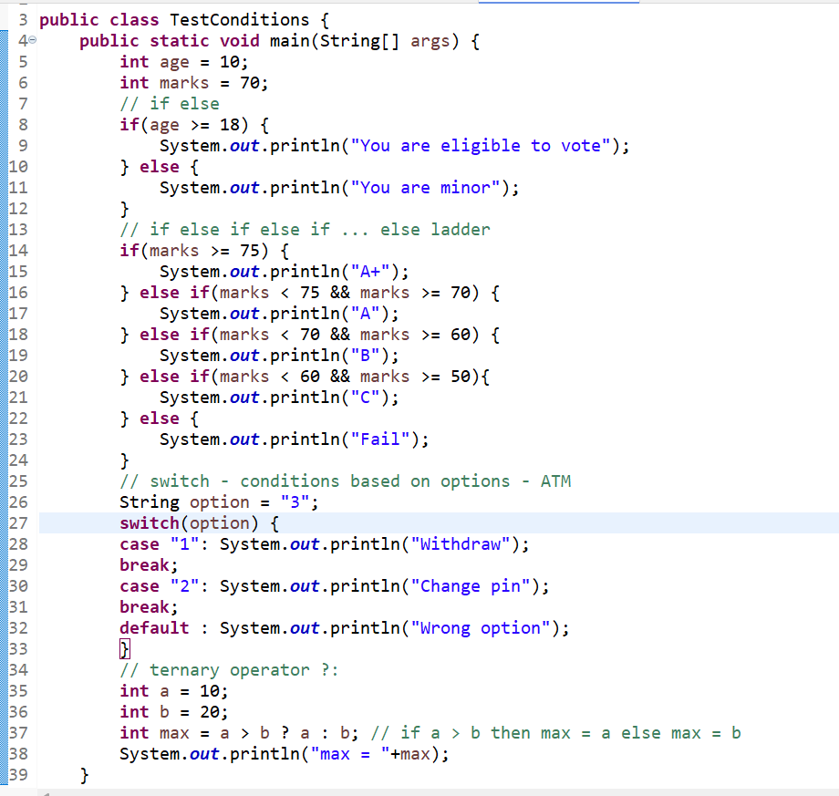
Output:
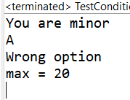

Switch options can be of below types
- int | byte | short | long
- char
- String
You can use scope for each case, so that you can declare variables belong to specific case.
case 1: int x = 20;
break;
case 2 : int x = 30 ; // CTE
break;
You can scope variables with { } and each case can have same variables
case 1 : {
int id = 20;
break;
}
case 2 : {
int id = 30;
break;
}

